**SRS Requirements(minimum 10 req.):**

**(FR,NFR & Constraint):**

**Functional Requirements:**

1. The bike should have an GPS system as well as a 3g/4g network based alert system built in to alert the user if something is wrong.
2. Bike should learn the frequently used roads and if the road is closed the user should get an alert.
3. Owner should be able to alert the customer service if the bike gets stolen.
4. The customer service should be able to provide the local authorities about the bikes position.
5. The bike should be able to present the user with possible routes and be able to guide the user according to the chosen path in real-time.
6. Bike should be able to calculate the intensity and workout time.
7. The bike should have autobalance.
8. The status, location, real time usage and sensors of the bike should be accessible for the user remotely.
9. The electric bike should eliminate waste of energy by regeneration. (See follow-up in constraints.)
10. The bike should give the user the possibility to choose the level of help distributed by the motor.
11. The electric bike should have all the benefits of a traditional bike.

**Non-Functional Requirements:**

1. Bike should be accessible for the user 24/7.
2. The using of the bike, including maintenance should be easy and non requiring for the user.
3. Using the functions in the bike should not be complicated.
4. The battery should be easy to carry.
5. The bike should reduce the harm on the environment by making more people use a bicycle as their main transport solution.
6. Improve the health for both the users and as well the non-users whose environment are positively affected by the reduced traffic and cleaner air this accomplishes.

**Constraint:**

1. the System should be able to have multiple user accounts.
2. Bike should be in different sizes for different users.
3. The battery should be easy and fast to replace without requiring mechanical knowledge or additional tools.
4. The battery should be easy to charge inside the user’s home
5. The bike should give the user the option to charge the battery manually when pedaling.
6. The bike should be able to recognize when a registered users phone and or smart-watch is close to it and unlock itself.
7. The bike should be able to unlock using fingerprint authorisation.
8. The bike should take care of the otherwise wasted energy while braking to regenerate the battery.

**User Stories(minimum 10 stories):**

1. As an elderly i need a bike that is semiAutomatic so i can paddle easier.
2. As an exchange student in an unfamiliar town I would like the bike to have an inbuilt navigation system so i don’t get lost.
3. As an user i want to get notification if unauthorized person uses my bike”steals it” and an easy way to provide the local authorities with the bikes location.
4. As a person whose bike got broken in middle of the road 3 time i need my bike to notify me if its has any problem that should be repaired.
5. As a person that uses ebike it will be nice to have a bike that charges itself when i’m pedaling so i don’t have to put it to charge every night.
6. As an athlete i want  my bike should keep track of my physical activity so i can improve my workout.
7. As an elderly the bike should be easy to use so i don’t get confuse with all those technology.
8. As a parent to 3 year old, it will be nice if the bike has autobalance so it will be easier to ride for children.
9. As a user i want the bike to connected to my phone to avoid having to always carry a separate key for it.
10. As an employee I want to ride my bike everyday and be aware of the accidents in the traffic to avoid being late to work.

**Requirements Template:**

1. 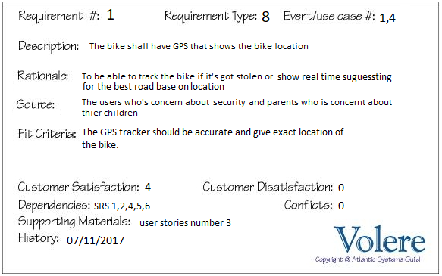
2. 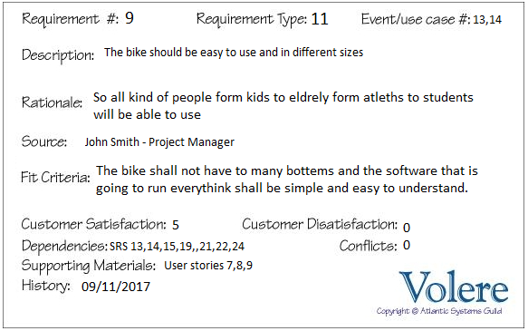

**EARS Structured Text:**

1. When the owner contact customer service that the bike got stolen, the customer service shall contact to authorities and provide them the bikes’ position.
2. If the bike needs repair, then the bike shall notify to owner.
3. While cycling , if the battery gets lower than 10% , the system shall start charging the battery when paddling.
4. Where the GPS function is on and location to go has been selected, the user shall get possible routes and the bike shall be able to guide the user in real-time.

**Reflection(max. 400 world):**

1. Yes, it did. by adding GPS in the functional requirement, we added more functions like we give ability to customer service to locate the bike and contact the authorities and at the same time we change the requirements template
2. We didn’t found difficulties in writing template and structured text since template and structured text is somehow based on SRS requirement , but we found difficulties to coming up with user stories since we don’t have any real users or stakeholders.
3. The benefits from all requirements that gave us better understanding on what kind of function should system have without tying us to special design. The one of the drawbacks of all requirements that we have to do write it without having any users or any stakeholders.